# Human Chromosome Variation

### Isaac McPadden

## Introduction

### Project Description

For my project I used 1000 Genomes (<https://www.internationalgenome.org/>) genetics data to measure genetic variation in each of the 24 (01-22, X, and Y) human chromosomes. The two goals for this project were to determine which chromosome experienced the highest amount of genetic variation and to determine how many mutations in each chromosome had high impact.

### Biochemistry and Genetics Primer

To understand the genetics data and results, a short primer on biochemistry is needed. I have a Bachelor of Arts in Biochemistry and all of the following information is common knowledge in the field. Nonetheless, any information included in this section can be found in Biochemistry, Fourth Edition, by Voet and Voet.

DNA (deoxyribonucleic acid) is the molecule that holds the heritable information passed from person to person. A DNA molecule is a pair of strands of polymers of nucleic acids. Nucleic acids have three main building blocks, an acidic phosphate group, a deoxyribose (pentagonal carbohydrate monomer with a missing oxygen atom), and a nitrogenous base. The sequence of nitrogenous bases are what hold the information and they come in pairs. A's on one strand correspond to T's on the other and vice-versa. C's on one strand correspond to G's on the other and vice-versa. The letters are abbreviations of the names of nitrogenous bases. The pairs together are called *base pairs* and are the genetic equivalent of a bit.

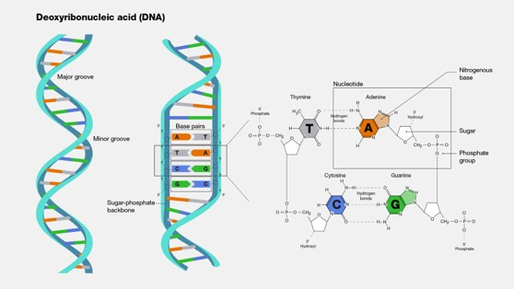

DNA is "read" by transcribing it to single stranded RNA which are fed to cell machinery called ribosomes. RNA trades out T for U and the ribose is not missing an oxygen atom. Ribosomes read the RNA 3 bases at a time and construct proteins by matching the trio with amino acids tied to their own RNA sequences.

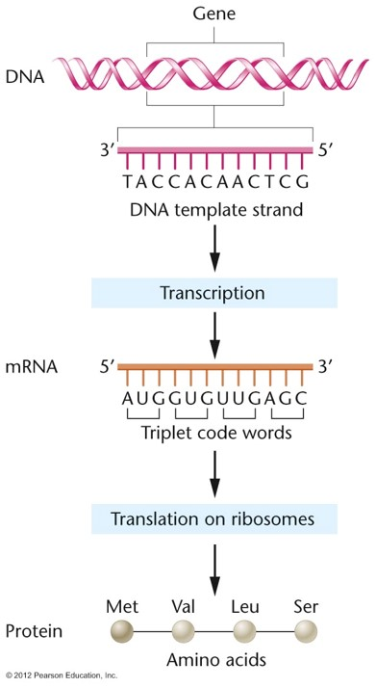

DNA base trios to their corresponding amino acids:

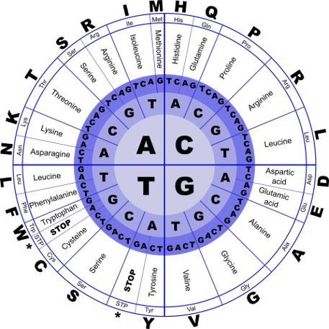

There are 64 possible base pair trios but only 20 amino acids used by humans so there is some redundancy built into the genetics system. Base pair trios are called *codons*, both in RNA and DNA.

Damage to DNA can cause mutations which can cause changes to what proteins are produced by a gene. Changes to proteins can cause changes to traits of a person but can also be the cause of genetic diseases. Substitutions are mutations where a single base pair is switched to another. That includes inversions where an A-T becomes a T-A pair. Substitutions can result in a single amino acid change in a protein, but because of the redundancy in the genetics system, often the substitution will do nothing. Insertions are where one or more base pairs get inserted into the sequence and deletions are where one or more base pairs are removed from a sequence. The consequences of insertions and deletions (indels) are reading frame shifts. This can completely change the amino acid sequence and protein length, it can introduce a new protein by creating a start codon, or it can disable a protein by deleting its start codon.

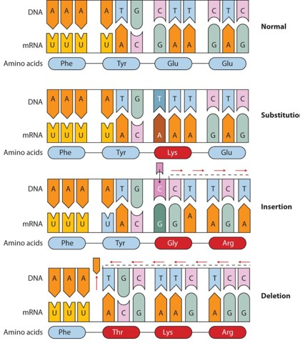

Much of a person's DNA is non-coding so the vast majority of mutations have little to no effect on a person.

## The Data

The 1000 Genomes project (<https://www.internationalgenome.org/>) has many genetics data sets. I used the "1000 Genomes 30x on GRCh38" dataset which is based on the Human Genome Project's (HGP) GRCh38 build of the human genome. GRCh38 is short for Genome Reference Consortium Human Build 38. The 1000 Genomes 30x on GRCh38 is an annotated dataset that contains a list of variants one each chromosome. A variant is any deviation from the sequence of a reference genome, in this case the Human Genome Project's GRCh38 build. The reference genome sequence is 3.1 GB (gigabytes, gigabases, either one works here) of G’s, A’s, T’s, and C’s. Annotating a whole genome would be many times more data so sequencing companies track the differences from the reference genomes and only annotate that. Even so, the annotated variants of the 1000 Genomes 30x on GRCh38 dataset consist of 24 text files (one for each human chromosome; 01-22, X, and Y) adding up to almost 60 GB (only gigabytes in this case) of data. In addition to the 1000 genomes data, I made a CSV from the Human Genome Project site listing how many base pairs each chromosome has for doing relative size calculations on each chromosome. (<https://www.ncbi.nlm.nih.gov/assembly/GCF_000001405.40/#/st_Primary-Assembly>).

## Summary of Initial Data Cleaning and Processing

Because the initial dataset was 60 GB, I had to do a considerable amount of data cleaning to make it usable. I opted to do this initial cleaning outside of a Jupyter notebook, mainly because I don't have the Jupyter and Python Venv set up on my desktop (I do all my school work on my laptop usually because I need it to be portable) and because my desktop hardware is heavy duty for gaming and photo processing.  
To start, I used "Text File Split", a free program on the Microsoft Store, to split each chromosome's .txt file into many smaller text files with 1,000,000 lines of data each. This allowed me to open the text files and see which columns were there and which columns I could remove. From there, I removed the columns I did not need (see screenshot below or gene_data_cleaning.py in the github repository). This reduced the 60 GB of data to 12 GB of data.

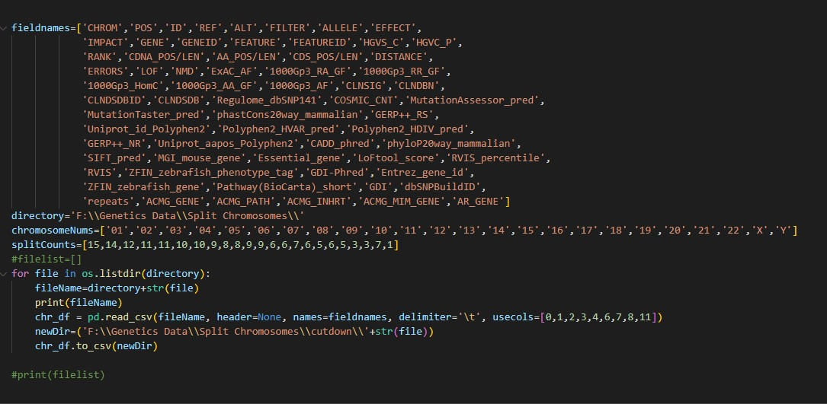

After that, I merged the separated text files back into 24 CSV files using the command line.

File merge commands in command line (NN is the chromosome number, 01-22 or X or Y):

cd <chromosomeNN text files directory>

copy * chrNN.csv

From there, I loaded each chromosome csv into a dataframe and ran pd.value_counts() on each column. I combined the value counts into a nested dictionary and saved that to a pickle file. Unfortunately the pickle file was still 3 GB so I had to drop all columns containing any GATC seqences (see screenshot below or gene_data_cleaning_2.py in the github repository). I finally had a pickle file that was small enough (111 MB) for use in a Jupyter notebook.

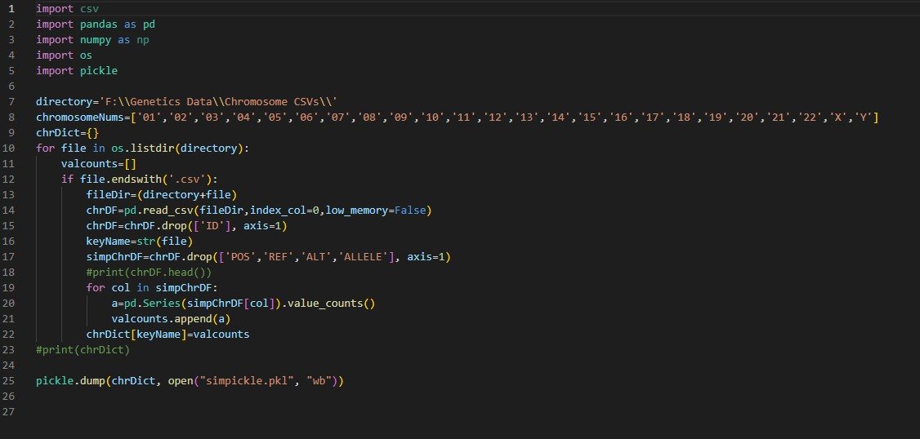

## Data Analysis

To start with, import packages and load in the pickle file, named simpickle.pkl because it is the simplified pickle file and I like portmanteaus.

!pip install matplotlib  
!pip install wordcloud  
import pandas as pd  
import numpy as np  
import os  
import pickle  
import matplotlib as mpl  
import matplotlib.pyplot as plt  
from wordcloud import WordCloud  
import seaborn as sns  
sns.set()

Code Output is in Appendix I

ax = totalCountsDF.plot.bar(x='Chromosome',y='Variant_Percentage', rot=90, title="Genetic Variant Count per Chromosome as a \nPercentage of Total Base Pairs")

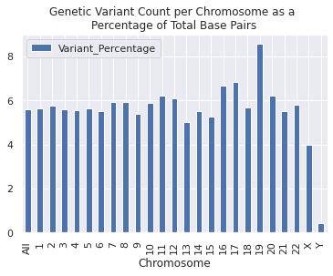

Chromosome 19 has the highest percentage of variants at 8 percent while Chromosome Y has the lowest at less than 1 percent. Most chromosomes have a variant count of about 6 percent. Chromosome X has a noticeably low variant percentage of 4 percent.

ax2 = totalCountsDF.plot.bar(x='Chromosome',y='High_Impact_Percentage', rot=90, title="High Impact Genetic Variant Count per Chromosome as a \nPercentage of Total Base Pairs")

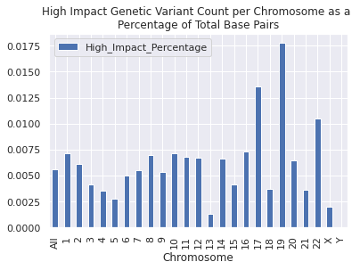

Chromosome 19 has the highest proportion of high impact variants at a little over 0.0175 percent. Most are close to either 0.0050 percent or 0.0030 percent. Chromosome 13 has noticeably low high impact variant percent at about 0.0012 percent, lower than even the X chromosome at around 0.0020 percent. Chromosomes 17 and 22 also have a greater proportion of high impact variants although not a great a proportion as Chromosome 19. Chromosome Y has a nearly 0 percentage of high impact variants.

ax3 = totalCountsDF.plot.bar(x='Chromosome',y='Variants_In_Genes_Percentage', rot=90, title="Variant Count Within Coding Genes per Chromosome as a \nPercentage of Total Base Pairs")

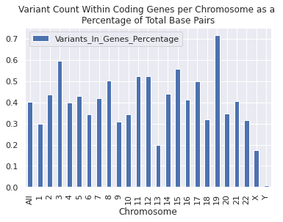

Variant count within coding genes resembles the distribution of variants overall, with Chromosome 19 being the highest at about 0.7 percent and Chromosome Y being the lowest at about 0.01 percent. Chromosome 13 has a very small proportion of variants within coding genes at 0.2 percent, just above chromosome X this time which has a proportion of variants in coding genes of about 0.18 percent.

plt.bar(totalCountsDF['Chromosome'], totalCountsDF['Variant_Percentage'], 0.5, label = 'All Variant Types Percentage')  
plt.bar(totalCountsDF['Chromosome'], totalCountsDF['Variants_In_Genes_Percentage'], 0.5, label = 'Variants In Coding Genes Percentage')  
plt.bar(totalCountsDF['Chromosome'], totalCountsDF['High_Impact_Percentage'], 0.5, label = 'High Impact Variant Percentage')   
  
plt.xlabel("Chromosome")  
plt.ylabel("Relative Percentage")  
plt.title("Variant Counts per Chromosome as a \nPercentage of Total Base Pairs")  
plt.legend()  
plt.show()

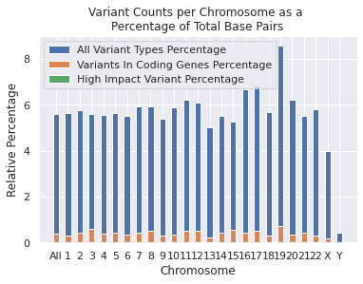

The bar graph shows relative percentage of variant types and impact levels. It sums them so actual numbers on the Y-axis are not valuable, but the size of the bars are. As can be seen in the bar graph, a majority of variants occur outside of coding genes and the percentage of high impact variants is imperceptible relative to all variants and variants within coding genes.

## Conclusion

Chromosome 19 experiences the most variance of all the chromosomes, suggesting it is a good target for finding possible causes of genetic disease or predisposition to other types of diseases. Chromosome 13 has a low proportion of high impact variants suggesting it may contain genes that if mutated could result in lethal consequences for humans or human cells. The X and Y chromosomes experience a low proportion of variants of each type as well. This is likely because they encode the differences between female and male humans and errors there would result in infertile humans so those variants can't be passed on to the next generation. The Y Chromosome has an especially small proportion of variants of all types. This is likely because the Y Chromosome is so small, there is no room for non-lethal and defertilizing variants to exist.

According to the human genome project, 41% of human DNA is GC pairs and 59% is AT pairs. So I made that into a word cloud.

nbases={'A':59,'C':41,'G':41,'T':59}  
  
wordcloud = WordCloud().generate_from_frequencies(nbases)  
  
# Display the generated image:  
# the matplotlib way:  
import matplotlib.pyplot as plt  
plt.imshow(wordcloud, interpolation='bilinear')  
plt.axis("off")  
plt.show()



Appendix I: Code output

Requirement already satisfied: matplotlib in /mnt/c/users/imcpa/OneDrive/Documents/Data Science at DU/DSTools1/lib/python3.8/site-packages (3.5.2)  
Requirement already satisfied: pillow>=6.2.0 in /mnt/c/users/imcpa/OneDrive/Documents/Data Science at DU/DSTools1/lib/python3.8/site-packages (from matplotlib) (9.1.1)  
Requirement already satisfied: packaging>=20.0 in /mnt/c/users/imcpa/OneDrive/Documents/Data Science at DU/DSTools1/lib/python3.8/site-packages (from matplotlib) (21.3)  
Requirement already satisfied: python-dateutil>=2.7 in /mnt/c/users/imcpa/OneDrive/Documents/Data Science at DU/DSTools1/lib/python3.8/site-packages (from matplotlib) (2.8.2)  
Requirement already satisfied: numpy>=1.17 in /mnt/c/users/imcpa/OneDrive/Documents/Data Science at DU/DSTools1/lib/python3.8/site-packages (from matplotlib) (1.22.3)  
Requirement already satisfied: pyparsing>=2.2.1 in /mnt/c/users/imcpa/OneDrive/Documents/Data Science at DU/DSTools1/lib/python3.8/site-packages (from matplotlib) (3.0.8)  
Requirement already satisfied: fonttools>=4.22.0 in /mnt/c/users/imcpa/OneDrive/Documents/Data Science at DU/DSTools1/lib/python3.8/site-packages (from matplotlib) (4.33.3)  
Requirement already satisfied: cycler>=0.10 in /mnt/c/users/imcpa/OneDrive/Documents/Data Science at DU/DSTools1/lib/python3.8/site-packages (from matplotlib) (0.11.0)  
Requirement already satisfied: kiwisolver>=1.0.1 in /mnt/c/users/imcpa/OneDrive/Documents/Data Science at DU/DSTools1/lib/python3.8/site-packages (from matplotlib) (1.4.2)  
Requirement already satisfied: six>=1.5 in /mnt/c/users/imcpa/OneDrive/Documents/Data Science at DU/DSTools1/lib/python3.8/site-packages (from python-dateutil>=2.7->matplotlib) (1.16.0)  
WARNING: You are using pip version 22.0.4; however, version 22.1.2 is available.  
You should consider upgrading via the '/mnt/c/users/imcpa/OneDrive/Documents/Data Science at DU/DSTools1/bin/python3 -m pip install --upgrade pip' command.  
Requirement already satisfied: wordcloud in /mnt/c/users/imcpa/OneDrive/Documents/Data Science at DU/DSTools1/lib/python3.8/site-packages (1.8.1)  
Requirement already satisfied: numpy>=1.6.1 in /mnt/c/users/imcpa/OneDrive/Documents/Data Science at DU/DSTools1/lib/python3.8/site-packages (from wordcloud) (1.22.3)  
Requirement already satisfied: pillow in /mnt/c/users/imcpa/OneDrive/Documents/Data Science at DU/DSTools1/lib/python3.8/site-packages (from wordcloud) (9.1.1)  
Requirement already satisfied: matplotlib in /mnt/c/users/imcpa/OneDrive/Documents/Data Science at DU/DSTools1/lib/python3.8/site-packages (from wordcloud) (3.5.2)  
Requirement already satisfied: cycler>=0.10 in /mnt/c/users/imcpa/OneDrive/Documents/Data Science at DU/DSTools1/lib/python3.8/site-packages (from matplotlib->wordcloud) (0.11.0)  
Requirement already satisfied: kiwisolver>=1.0.1 in /mnt/c/users/imcpa/OneDrive/Documents/Data Science at DU/DSTools1/lib/python3.8/site-packages (from matplotlib->wordcloud) (1.4.2)  
Requirement already satisfied: packaging>=20.0 in /mnt/c/users/imcpa/OneDrive/Documents/Data Science at DU/DSTools1/lib/python3.8/site-packages (from matplotlib->wordcloud) (21.3)  
Requirement already satisfied: pyparsing>=2.2.1 in /mnt/c/users/imcpa/OneDrive/Documents/Data Science at DU/DSTools1/lib/python3.8/site-packages (from matplotlib->wordcloud) (3.0.8)  
Requirement already satisfied: fonttools>=4.22.0 in /mnt/c/users/imcpa/OneDrive/Documents/Data Science at DU/DSTools1/lib/python3.8/site-packages (from matplotlib->wordcloud) (4.33.3)  
Requirement already satisfied: python-dateutil>=2.7 in /mnt/c/users/imcpa/OneDrive/Documents/Data Science at DU/DSTools1/lib/python3.8/site-packages (from matplotlib->wordcloud) (2.8.2)  
Requirement already satisfied: six>=1.5 in /mnt/c/users/imcpa/OneDrive/Documents/Data Science at DU/DSTools1/lib/python3.8/site-packages (from python-dateutil>=2.7->matplotlib->wordcloud) (1.16.0)  
WARNING: You are using pip version 22.0.4; however, version 22.1.2 is available.  
You should consider upgrading via the '/mnt/c/users/imcpa/OneDrive/Documents/Data Science at DU/DSTools1/bin/python3 -m pip install --upgrade pip' command.

pickleData = pickle.load( open( "simpickle.pkl", "rb" ) )

print(pickleData)

{'chr01.csv': [chr1 14053427  
Name: CHROM, dtype: int64, intergenic_region 5349797  
intron_variant 5163578  
downstream_gene_variant 1202395  
upstream_gene_variant 1193612  
intragenic_variant 749399  
 ...   
stop_lost&disruptive_inframe_deletion 1  
start_lost&conservative_inframe_insertion 1  
frameshift_variant&start_lost&splice_region_variant 1  
frameshift_variant&stop_gained&splice_region_variant 1  
stop_lost&splice_region_variant&conservative_inframe_deletion 1  
Name: EFFECT, Length: 75, dtype: int64, MODIFIER 13903103  
MODERATE 74668  
LOW 57828  
HIGH 17828  
Name: IMPACT, dtype: int64, transcript 7942462  
intergenic_region 5349797  
gene_variant 749428  
interaction 11740  
Name: FEATURE, dtype: int64], 'chr02.csv': [chr2 13961577  
Name: CHROM, dtype: int64, intron_variant 5432413  
intergenic_region 5259484  
intragenic_variant 1062786  
upstream_gene_variant 962662  
downstream_gene_variant 947611  
 ...   
splice_donor_variant&splice_region_variant&conservative_inframe_deletion&intron_variant 1  
splice_region_variant&downstream_gene_variant 1  
splice_acceptor_variant&splice_region_variant&conservative_inframe_deletion&intron_variant 1  
initiator_codon_variant&splice_region_variant 1  
start_lost&conservative_inframe_insertion 1  
Name: EFFECT, Length: 69, dtype: int64, MODIFIER 13849129  
MODERATE 55176  
LOW 42398  
HIGH 14874  
Name: IMPACT, dtype: int64, transcript 7628815  
intergenic_region 5259484  
gene_variant 1062824  
interaction 10453  
transcript﻿ 1  
Name: FEATURE, dtype: int64], 'chr03.csv': [chr3 11149042  
Name: CHROM, dtype: int64, intron_variant 4503237  
intergenic_region 3861920  
intragenic_variant 1184206  
downstream_gene_variant 691091  
upstream_gene_variant 682915  
 ...   
stop_gained&splice_region_variant&disruptive_inframe_insertion 1  
splice_acceptor_variant&splice_region_variant&conservative_inframe_deletion&intron_variant 1  
splice_donor_variant&5_prime_UTR_variant&intron_variant 1  
frameshift_variant&splice_acceptor_variant&splice_donor_variant&splice_region_variant&intron_variant 1  
stop_lost&splice_region_variant 1  
Name: EFFECT, Length: 68, dtype: int64, MODIFIER 11069445  
MODERATE 40043  
LOW 31303  
HIGH 8251  
Name: IMPACT, dtype: int64, transcript 6097987  
intergenic_region 3861920  
gene_variant 1184227  
interaction 4908  
Name: FEATURE, dtype: int64], 'chr04.csv': [chr4 10591957  
Name: CHROM, dtype: int64, intergenic_region 4737833  
intron_variant 3687485  
intragenic_variant 757502  
upstream_gene_variant 616037  
downstream_gene_variant 614436  
non_coding_transcript_exon_variant 68600  
3_prime_UTR_variant 45328  
missense_variant 25263  
synonymous_variant 14997  
5_prime_UTR_variant 9368  
structural_interaction_variant 4425  
splice_region_variant&intron_variant 4151  
5_prime_UTR_premature_start_codon_gain_variant 1265  
frameshift_variant 921  
splice_region_variant&non_coding_transcript_exon_variant 751  
missense_variant&splice_region_variant 669  
stop_gained 586  
disruptive_inframe_deletion 396  
splice_region_variant&synonymous_variant 382  
splice_donor_variant&intron_variant 348  
splice_acceptor_variant&intron_variant 330  
splice_region_variant 203  
disruptive_inframe_insertion 190  
conservative_inframe_deletion 153  
conservative_inframe_insertion 74  
start_lost 47  
stop_lost 25  
stop_retained_variant 22  
frameshift_variant&splice_region_variant 21  
splice_acceptor_variant&splice_region_variant&intron_variant&non_coding_transcript_exon_variant 17  
non_coding_transcript_variant 17  
frameshift_variant&stop_gained 16  
stop_gained&splice_region_variant 16  
splice_donor_variant&splice_region_variant&intron_variant 11  
splice_acceptor_variant&splice_region_variant&intron_variant 10  
frameshift_variant&start_lost 9  
splice_region_variant&disruptive_inframe_deletion 7  
bidirectional_gene_fusion 6  
splice_donor_variant&splice_region_variant&intron_variant&non_coding_transcript_exon_variant 6  
frameshift_variant&splice_acceptor_variant&splice_region_variant&intron_variant 4  
frameshift_variant&stop_lost 3  
frameshift_variant&splice_donor_variant&splice_region_variant&intron_variant 3  
initiator_codon_variant 3  
protein_protein_contact 3  
stop_lost&conservative_inframe_deletion 3  
start_lost&splice_region_variant 2  
stop_lost&splice_region_variant 2  
stop_gained&disruptive_inframe_insertion 2  
stop_gained&conservative_inframe_insertion 2  
initiator_codon_variant&non_canonical_start_codon 1  
splice_acceptor_variant&splice_region_variant&disruptive_inframe_deletion&intron_variant 1  
frameshift_variant&stop_lost&splice_region_variant 1  
frameshift_variant&start_lost&splice_region_variant 1  
gene_fusion 1  
splice_acceptor_variant&splice_region_variant&conservative_inframe_deletion&intron_variant 1  
splice_region_variant&conservative_inframe_deletion 1  
Name: EFFECT, dtype: int64, MODIFIER 10536606  
MODERATE 26753  
LOW 21775  
HIGH 6823  
Name: IMPACT, dtype: int64, transcript 5092187  
intergenic_region 4737833  
gene_variant 757509  
interaction 4428  
Name: FEATURE, dtype: int64], 'chr05.csv': [chr5 10283606  
Name: CHROM, dtype: int64, intergenic_region 4173842  
intron_variant 3803902  
intragenic_variant 783880  
upstream_gene_variant 661815  
downstream_gene_variant 660644  
 ...   
stop_lost&splice_region_variant 1  
splice_acceptor_variant&5_prime_UTR_variant&intron_variant 1  
splice_acceptor_variant&splice_region_variant&disruptive_inframe_deletion&intron_variant 1  
stop_gained&conservative_inframe_insertion 1  
start_lost&conservative_inframe_deletion 1  
Name: EFFECT, Length: 62, dtype: int64, MODIFIER 10221746  
MODERATE 30884  
LOW 25914  
HIGH 5062  
Name: IMPACT, dtype: int64, transcript 5323097  
intergenic_region 4173842  
gene_variant 783940  
interaction 2727  
Name: FEATURE, dtype: int64], 'chr06.csv': [chr6 9430386  
Name: CHROM, dtype: int64, intergenic_region 4034763  
intron_variant 3277205  
downstream_gene_variant 662829  
upstream_gene_variant 661989  
intragenic_variant 590030  
 ...   
splice_donor_variant&splice_region_variant&conservative_inframe_deletion&intron_variant 1  
splice_acceptor_variant&splice_region_variant&5_prime_UTR_variant&intron_variant 1  
gene_fusion 1  
splice_donor_variant&splice_region_variant&disruptive_inframe_deletion&intron_variant 1  
stop_lost&splice_region_variant&conservative_inframe_deletion 1  
Name: EFFECT, Length: 62, dtype: int64, MODIFIER 9358625  
MODERATE 35471  
LOW 27715  
HIGH 8575  
Name: IMPACT, dtype: int64, transcript 4799901  
intergenic_region 4034763  
gene_variant 590047  
interaction 5675  
Name: FEATURE, dtype: int64], 'chr07.csv': [chr7 9468709  
Name: CHROM, dtype: int64, intron_variant 3781258  
intergenic_region 3391514  
downstream_gene_variant 705639  
upstream_gene_variant 697360  
intragenic_variant 670119  
 ...   
frameshift_variant&splice_acceptor_variant&splice_donor_variant&splice_region_variant&intron_variant 1  
start_lost&disruptive_inframe_insertion 1  
splice_region_variant&conservative_inframe_insertion 1  
stop_gained&disruptive_inframe_deletion 1  
splice_region_variant&conservative_inframe_deletion 1  
Name: EFFECT, Length: 67, dtype: int64, MODIFIER 9391860  
MODERATE 37836  
LOW 30283  
HIGH 8730  
Name: IMPACT, dtype: int64, transcript 5401588  
intergenic_region 3391514  
gene_variant 670150  
interaction 5457  
Name: FEATURE, dtype: int64], 'chr08.csv': [chr8 8614681  
Name: CHROM, dtype: int64, intron_variant 3376717  
intergenic_region 3150101  
intragenic_variant 727946  
downstream_gene_variant 596351  
upstream_gene_variant 588630  
 ...   
5_prime_UTR_truncation&exon_loss_variant 1  
splice_acceptor_variant&5_prime_UTR_variant&intron_variant 1  
start_lost&conservative_inframe_insertion 1  
frameshift_variant&stop_lost&splice_region_variant 1  
splice_acceptor_variant&splice_region_variant&conservative_inframe_deletion&intron_variant 1  
Name: EFFECT, Length: 63, dtype: int64, MODIFIER 8557239  
MODERATE 25325  
LOW 21965  
HIGH 10152  
Name: IMPACT, dtype: int64, transcript 4728458  
intergenic_region 3150101  
gene_variant 727985  
interaction 8137  
Name: FEATURE, dtype: int64], 'chr09.csv': [chr9 7462036  
Name: CHROM, dtype: int64, intergenic_region 3183293  
intron_variant 2534950  
downstream_gene_variant 570459  
upstream_gene_variant 566665  
intragenic_variant 430236  
 ...   
splice_acceptor_variant&splice_region_variant&conservative_inframe_deletion&intron_variant 1  
splice_donor_variant&splice_region_variant&disruptive_inframe_deletion&intron_variant 1  
splice_donor_variant&splice_region_variant&5_prime_UTR_variant&intron_variant 1  
stop_lost&splice_region_variant 1  
stop_lost&splice_region_variant&conservative_inframe_deletion 1  
Name: EFFECT, Length: 64, dtype: int64, MODIFIER 7398898  
MODERATE 30347  
LOW 25319  
HIGH 7472  
Name: IMPACT, dtype: int64, transcript 3843322  
intergenic_region 3183293  
gene_variant 430246  
interaction 5175  
Name: FEATURE, dtype: int64], 'chr10.csv': [chr10 7881973  
Name: CHROM, dtype: int64, intergenic_region 3195460  
intron_variant 3000050  
downstream_gene_variant 528778  
upstream_gene_variant 527086  
intragenic_variant 459411  
 ...   
splice_acceptor_variant&splice_region_variant&disruptive_inframe_deletion&intron_variant 1  
stop_lost&splice_region_variant 1  
start_lost&splice_region_variant&conservative_inframe_deletion 1  
splice_donor_variant&splice_region_variant&disruptive_inframe_deletion&intron_variant 1  
splice_donor_variant&splice_region_variant&3_prime_UTR_variant&intron_variant 1  
Name: EFFECT, Length: 66, dtype: int64, MODIFIER 7822173  
MODERATE 27443  
LOW 22848  
HIGH 9509  
Name: IMPACT, dtype: int64, transcript 4219694  
intergenic_region 3195460  
gene_variant 459432  
interaction 7387  
Name: FEATURE, dtype: int64], 'chr11.csv': [chr11 8401457  
Name: CHROM, dtype: int64, intergenic_region 3015909  
intron_variant 2906571  
downstream_gene_variant 770821  
upstream_gene_variant 769794  
intragenic_variant 709370  
 ...   
start_lost&conservative_inframe_deletion 1  
5_prime_UTR_truncation&exon_loss_variant 1  
splice_donor_variant&3_prime_UTR_variant&intron_variant 1  
start_lost&conservative_inframe_insertion 1  
splice_region_variant&downstream_gene_variant 1  
Name: EFFECT, Length: 68, dtype: int64, MODIFIER 8311419  
MODERATE 45641  
LOW 35151  
HIGH 9246  
Name: IMPACT, dtype: int64, transcript 4670462  
intergenic_region 3015909  
gene_variant 709409  
interaction 5677  
Name: FEATURE, dtype: int64], 'chr12.csv': [chr12 8130250  
Name: CHROM, dtype: int64, intron_variant 3079886  
intergenic_region 2756441  
intragenic_variant 700417  
downstream_gene_variant 683192  
upstream_gene_variant 680918  
 ...   
splice_donor_variant&splice_region_variant&conservative_inframe_deletion&intron_variant 1  
transcript_ablation 1  
splice_acceptor_variant&splice_donor_variant&splice_region_variant&conservative_inframe_deletion&intron_variant 1  
splice_acceptor_variant&splice_donor_variant&intron_variant 1  
start_lost&conservative_inframe_deletion 1  
Name: EFFECT, Length: 66, dtype: int64, MODIFIER 8058186  
MODERATE 33759  
LOW 29322  
HIGH 8983  
Name: IMPACT, dtype: int64, transcript 4667358  
intergenic_region 2756441  
gene_variant 700442  
interaction 6009  
Name: FEATURE, dtype: int64], 'chr13.csv': [chr13 5756600  
Name: CHROM, dtype: int64, intergenic_region 3089603  
intron_variant 1731958  
upstream_gene_variant 310203  
downstream_gene_variant 307622  
intragenic_variant 227650  
non_coding_transcript_exon_variant 39441  
3_prime_UTR_variant 22383  
missense_variant 11007  
synonymous_variant 6954  
5_prime_UTR_variant 4160  
splice_region_variant&intron_variant 2118  
5_prime_UTR_premature_start_codon_gain_variant 619  
splice_region_variant&non_coding_transcript_exon_variant 421  
structural_interaction_variant 402  
frameshift_variant 318  
missense_variant&splice_region_variant 275  
stop_gained 242  
splice_donor_variant&intron_variant 206  
splice_acceptor_variant&intron_variant 204  
disruptive_inframe_deletion 185  
splice_region_variant&synonymous_variant 155  
splice_region_variant 90  
conservative_inframe_deletion 86  
disruptive_inframe_insertion 76  
conservative_inframe_insertion 63  
protein_protein_contact 24  
start_lost 23  
frameshift_variant&splice_region_variant 18  
non_coding_transcript_variant 16  
splice_acceptor_variant&splice_region_variant&intron_variant 11  
stop_gained&splice_region_variant 8  
splice_acceptor_variant&splice_region_variant&intron_variant&non_coding_transcript_exon_variant 8  
stop_lost 7  
splice_donor_variant&splice_region_variant&intron_variant&non_coding_transcript_exon_variant 6  
bidirectional_gene_fusion 5  
frameshift_variant&stop_gained 5  
frameshift_variant&splice_donor_variant&splice_region_variant&intron_variant 4  
splice_donor_variant&splice_region_variant&intron_variant 4  
gene_fusion 3  
frameshift_variant&splice_acceptor_variant&splice_region_variant&intron_variant 3  
stop_retained_variant 3  
initiator_codon_variant 2  
frameshift_variant&start_lost 2  
splice_donor_variant&5_prime_UTR_variant&intron_variant 1  
splice_region_variant&conservative_inframe_deletion 1  
splice_region_variant&disruptive_inframe_insertion 1  
start_lost&conservative_inframe_deletion 1  
start_lost&splice_region_variant 1  
splice_donor_variant&splice_region_variant&disruptive_inframe_deletion&intron_variant 1  
splice_acceptor_variant&splice_region_variant&5_prime_UTR_variant&intron_variant 1  
Name: EFFECT, dtype: int64, MODIFIER 5733036  
MODERATE 11694  
LOW 10362  
HIGH 1508  
Name: IMPACT, dtype: int64, intergenic_region 3089603  
transcript 2438913  
gene_variant 227658  
interaction 426  
Name: FEATURE, dtype: int64], 'chr14.csv': [chr14 5948454  
Name: CHROM, dtype: int64, intron_variant 2073750  
intergenic_region 1807833  
downstream_gene_variant 731348  
upstream_gene_variant 694346  
intragenic_variant 477909  
 ...   
splice_region_variant&stop_retained_variant 1  
splice_donor_variant&splice_region_variant&5_prime_UTR_variant&intron_variant 1  
exon_loss_variant&splice_region_variant 1  
stop_lost&conservative_inframe_insertion 1  
splice_donor_variant&splice_region_variant&conservative_inframe_deletion&intron_variant 1  
Name: EFFECT, Length: 73, dtype: int64, MODIFIER 5883699  
MODERATE 33778  
LOW 23844  
HIGH 7133  
Name: IMPACT, dtype: int64, transcript 3659050  
intergenic_region 1807833  
gene_variant 477927  
interaction 3644  
Name: FEATURE, dtype: int64], 'chr15.csv': [chr15 5379964  
Name: CHROM, dtype: int64, intron_variant 2272152  
intergenic_region 1311179  
intragenic_variant 573350  
downstream_gene_variant 527253  
upstream_gene_variant 522776  
non_coding_transcript_exon_variant 73026  
3_prime_UTR_variant 42899  
missense_variant 23729  
synonymous_variant 14208  
5_prime_UTR_variant 7131  
splice_region_variant&intron_variant 4122  
structural_interaction_variant 2141  
5_prime_UTR_premature_start_codon_gain_variant 1001  
splice_region_variant&non_coding_transcript_exon_variant 791  
frameshift_variant 759  
missense_variant&splice_region_variant 665  
stop_gained 481  
splice_donor_variant&intron_variant 372  
splice_region_variant&synonymous_variant 371  
disruptive_inframe_deletion 363  
splice_acceptor_variant&intron_variant 295  
conservative_inframe_deletion 218  
splice_region_variant 143  
disruptive_inframe_insertion 130  
conservative_inframe_insertion 120  
start_lost 35  
frameshift_variant&stop_gained 23  
stop_lost 23  
non_coding_transcript_variant 22  
frameshift_variant&splice_region_variant 18  
protein_protein_contact 18  
stop_gained&splice_region_variant 17  
frameshift_variant&splice_donor_variant&splice_region_variant&intron_variant 15  
splice_donor_variant&splice_region_variant&intron_variant&non_coding_transcript_exon_variant 15  
bidirectional_gene_fusion 14  
stop_retained_variant 12  
splice_acceptor_variant&splice_region_variant&intron_variant 10  
splice_donor_variant&splice_region_variant&intron_variant 8  
gene_fusion 8  
splice_acceptor_variant&splice_region_variant&intron_variant&non_coding_transcript_exon_variant 7  
splice_region_variant&conservative_inframe_deletion 5  
frameshift_variant&start_lost 5  
splice_region_variant&disruptive_inframe_deletion 4  
stop_lost&splice_region_variant 4  
initiator_codon_variant 4  
frameshift_variant&splice_acceptor_variant&splice_region_variant&intron_variant 4  
start_lost&conservative_inframe_deletion 3  
splice_acceptor_variant&splice_region_variant&conservative_inframe_deletion&intron_variant 3  
frameshift_variant&stop_lost&splice_region_variant 2  
splice_acceptor_variant&splice_region_variant&5_prime_UTR_variant&intron_variant 1  
splice_region_variant&stop_retained_variant 1  
stop_gained&disruptive_inframe_deletion 1  
splice_acceptor_variant&splice_donor_variant&splice_region_variant&intron_variant 1  
frameshift_variant&splice_acceptor_variant&splice_donor_variant&splice_region_variant&intron_variant 1  
splice_acceptor_variant&3_prime_UTR_variant&intron_variant 1  
start_lost&splice_region_variant 1  
splice_donor_variant&splice_region_variant&conservative_inframe_deletion&intron_variant 1  
initiator_codon_variant&splice_region_variant 1  
frameshift_variant&stop_lost 1  
Name: EFFECT, dtype: int64, MODIFIER 5329788  
MODERATE 25234  
LOW 20654  
HIGH 4288  
Name: IMPACT, dtype: int64, transcript 3493254  
intergenic_region 1311179  
gene_variant 573372  
interaction 2159  
Name: FEATURE, dtype: int64], 'chr16.csv': [chr16 6140757  
Name: CHROM, dtype: int64, intron_variant 2484202  
intergenic_region 1714259  
downstream_gene_variant 673882  
upstream_gene_variant 671319  
intragenic_variant 381783  
 ...   
stop_gained&disruptive_inframe_insertion 1  
stop_gained&splice_donor_variant&splice_region_variant&disruptive_inframe_deletion&intron_variant 1  
stop_lost&disruptive_inframe_insertion 1  
splice_region_variant&stop_retained_variant 1  
splice_acceptor_variant&splice_donor_variant&splice_region_variant&intron_variant&non_coding_transcript_exon_variant 1  
Name: EFFECT, Length: 75, dtype: int64, MODIFIER 6067639  
MODERATE 35695  
LOW 30641  
HIGH 6782  
Name: IMPACT, dtype: int64, transcript 4040642  
intergenic_region 1714259  
gene_variant 381801  
interaction 4055  
Name: FEATURE, dtype: int64], 'chr17.csv': [chr17 5738905  
Name: CHROM, dtype: int64, intron_variant 2180550  
intergenic_region 1453082  
downstream_gene_variant 728046  
upstream_gene_variant 724892  
intragenic_variant 418494  
 ...   
splice_donor_variant&splice_region_variant&3_prime_UTR_variant&intron_variant 1  
splice_region_variant&downstream_gene_variant 1  
splice_region_variant&stop_retained_variant 1  
splice_acceptor_variant&splice_region_variant&conservative_inframe_deletion&intron_variant 1  
splice_acceptor_variant&splice_donor_variant&splice_region_variant&intron_variant 1  
Name: EFFECT, Length: 68, dtype: int64, MODIFIER 5651017  
MODERATE 41099  
LOW 35384  
HIGH 11405  
Name: IMPACT, dtype: int64, transcript 3859221  
intergenic_region 1453082  
gene_variant 418544  
interaction 8058  
Name: FEATURE, dtype: int64], 'chr18.csv': [chr18 4572260  
Name: CHROM, dtype: int64, intergenic_region 2065539  
intron_variant 1595926  
downstream_gene_variant 284864  
upstream_gene_variant 282536  
intragenic_variant 256058  
non_coding_transcript_exon_variant 36183  
3_prime_UTR_variant 24597  
missense_variant 10005  
synonymous_variant 6372  
5_prime_UTR_variant 3823  
structural_interaction_variant 2058  
splice_region_variant&intron_variant 1702  
5_prime_UTR_premature_start_codon_gain_variant 506  
splice_region_variant&non_coding_transcript_exon_variant 389  
frameshift_variant 299  
missense_variant&splice_region_variant 244  
stop_gained 193  
splice_donor_variant&intron_variant 164  
splice_region_variant&synonymous_variant 155  
splice_acceptor_variant&intron_variant 131  
disruptive_inframe_deletion 129  
splice_region_variant 79  
conservative_inframe_deletion 64  
disruptive_inframe_insertion 61  
conservative_inframe_insertion 44  
non_coding_transcript_variant 22  
start_lost 22  
protein_protein_contact 14  
frameshift_variant&splice_region_variant 9  
splice_donor_variant&splice_region_variant&intron_variant&non_coding_transcript_exon_variant 9  
frameshift_variant&stop_gained 6  
splice_acceptor_variant&splice_region_variant&intron_variant&non_coding_transcript_exon_variant 6  
frameshift_variant&splice_donor_variant&splice_region_variant&intron_variant 6  
stop_gained&splice_region_variant 6  
splice_donor_variant&splice_region_variant&intron_variant 5  
bidirectional_gene_fusion 5  
stop_lost 4  
gene_fusion 4  
initiator_codon_variant 4  
splice_acceptor_variant&splice_region_variant&disruptive_inframe_deletion&intron_variant 2  
stop_retained_variant 2  
frameshift_variant&start_lost 2  
frameshift_variant&splice_acceptor_variant&splice_region_variant&intron_variant 2  
splice_acceptor_variant&splice_region_variant&intron_variant 2  
stop_gained&disruptive_inframe_insertion 1  
splice_donor_variant&splice_region_variant&conservative_inframe_deletion&intron_variant 1  
splice_region_variant&conservative_inframe_deletion 1  
stop_lost&splice_region_variant 1  
start_lost&conservative_inframe_insertion 1  
splice_region_variant&downstream_gene_variant 1  
splice_acceptor_variant&splice_donor_variant&splice_region_variant&intron_variant 1  
Name: EFFECT, dtype: int64, MODIFIER 4549548  
MODERATE 10548  
LOW 9210  
HIGH 2954  
Name: IMPACT, dtype: int64, transcript 2248582  
intergenic_region 2065539  
gene_variant 256067  
interaction 2072  
Name: FEATURE, dtype: int64], 'chr19.csv': [chr19 5025452  
Name: CHROM, dtype: int64, intron_variant 1739413  
intergenic_region 1018240  
downstream_gene_variant 806542  
upstream_gene_variant 793569  
intragenic_variant 420258  
 ...   
splice_acceptor_variant&5_prime_UTR_variant&intron_variant 1  
start_lost&splice_region_variant&conservative_inframe_deletion 1  
start_lost&conservative_inframe_insertion 1  
start_lost&conservative_inframe_deletion 1  
splice_donor_variant&5_prime_UTR_variant&intron_variant 1  
Name: EFFECT, Length: 74, dtype: int64, MODIFIER 4912823  
MODERATE 56200  
LOW 46014  
HIGH 10415  
Name: IMPACT, dtype: int64, transcript 3581346  
intergenic_region 1018240  
gene_variant 420303  
interaction 5563  
Name: FEATURE, dtype: int64], 'chr20.csv': [chr20 4021075  
Name: CHROM, dtype: int64, intergenic_region 1686894  
intron_variant 1319291  
downstream_gene_variant 345250  
upstream_gene_variant 341023  
intragenic_variant 223942  
non_coding_transcript_exon_variant 31041  
3_prime_UTR_variant 30776  
missense_variant 16325  
synonymous_variant 11090  
5_prime_UTR_variant 5980  
structural_interaction_variant 2844  
splice_region_variant&intron_variant 2651  
5_prime_UTR_premature_start_codon_gain_variant 842  
frameshift_variant 446  
missense_variant&splice_region_variant 439  
splice_region_variant&non_coding_transcript_exon_variant 390  
splice_region_variant&synonymous_variant 303  
stop_gained 282  
disruptive_inframe_deletion 246  
splice_donor_variant&intron_variant 213  
splice_acceptor_variant&intron_variant 192  
splice_region_variant 138  
disruptive_inframe_insertion 107  
conservative_inframe_deletion 104  
conservative_inframe_insertion 72  
start_lost 34  
protein_protein_contact 29  
splice_acceptor_variant&splice_region_variant&intron_variant 15  
non_coding_transcript_variant 11  
stop_lost 11  
gene_fusion 11  
splice_donor_variant&splice_region_variant&intron_variant&non_coding_transcript_exon_variant 8  
frameshift_variant&stop_gained 8  
stop_gained&splice_region_variant 7  
initiator_codon_variant 6  
frameshift_variant&start_lost 5  
frameshift_variant&splice_region_variant 5  
splice_acceptor_variant&splice_region_variant&intron_variant&non_coding_transcript_exon_variant 5  
stop_retained_variant 4  
splice_region_variant&disruptive_inframe_deletion 4  
frameshift_variant&splice_acceptor_variant&splice_region_variant&intron_variant 4  
splice_donor_variant&splice_region_variant&intron_variant 3  
start_lost&conservative_inframe_deletion 3  
frameshift_variant&stop_lost 3  
stop_lost&splice_region_variant 3  
stop_gained&conservative_inframe_insertion 2  
frameshift_variant&splice_donor_variant&splice_region_variant&intron_variant 2  
frameshift_variant&stop_gained&splice_region_variant 2  
splice_acceptor_variant&5_prime_UTR_truncation&exon_loss_variant&splice_region_variant&intron_variant 1  
start_lost&splice_region_variant 1  
feature_ablation 1  
bidirectional_gene_fusion 1  
splice_region_variant&conservative_inframe_deletion 1  
splice_acceptor_variant&splice_region_variant&disruptive_inframe_deletion&intron_variant 1  
frameshift_variant&stop_lost&splice_region_variant 1  
frameshift_variant&start_lost&splice_region_variant 1  
splice_donor_variant&splice_region_variant&disruptive_inframe_deletion&intron_variant 1  
Name: EFFECT, dtype: int64, MODIFIER 3984208  
MODERATE 17298  
LOW 15424  
HIGH 4145  
Name: IMPACT, dtype: int64, transcript 2107353  
intergenic_region 1686894  
gene_variant 223955  
interaction 2873  
Name: FEATURE, dtype: int64], 'chr21.csv': [chr21 2586151  
Name: CHROM, dtype: int64, intergenic_region 1037051  
intron_variant 867433  
downstream_gene_variant 221920  
upstream_gene_variant 213186  
intragenic_variant 189527  
non_coding_transcript_exon_variant 25845  
3_prime_UTR_variant 12250  
missense_variant 7189  
synonymous_variant 4884  
5_prime_UTR_variant 2431  
splice_region_variant&intron_variant 1400  
structural_interaction_variant 957  
splice_region_variant&non_coding_transcript_exon_variant 357  
5_prime_UTR_premature_start_codon_gain_variant 336  
frameshift_variant 281  
missense_variant&splice_region_variant 197  
stop_gained 138  
splice_donor_variant&intron_variant 135  
splice_region_variant&synonymous_variant 117  
disruptive_inframe_deletion 117  
splice_acceptor_variant&intron_variant 101  
splice_region_variant 65  
conservative_inframe_deletion 48  
disruptive_inframe_insertion 46  
conservative_inframe_insertion 42  
start_lost 16  
splice_donor_variant&splice_region_variant&intron_variant&non_coding_transcript_exon_variant 10  
non_coding_transcript_variant 8  
splice_acceptor_variant&splice_region_variant&intron_variant 7  
frameshift_variant&splice_region_variant 7  
frameshift_variant&stop_gained 6  
stop_retained_variant 5  
gene_fusion 5  
splice_acceptor_variant&splice_region_variant&intron_variant&non_coding_transcript_exon_variant 4  
frameshift_variant&start_lost 3  
splice_donor_variant&splice_region_variant&intron_variant 3  
stop_lost&conservative_inframe_deletion 2  
stop_gained&splice_region_variant 2  
splice_donor_variant&splice_region_variant&5_prime_UTR_variant&intron_variant 2  
splice_acceptor_variant&splice_region_variant&conservative_inframe_deletion&intron_variant 2  
stop_lost 2  
bidirectional_gene_fusion 2  
initiator_codon_variant 1  
frameshift_variant&splice_donor_variant&splice_region_variant&intron_variant 1  
splice_region_variant&disruptive_inframe_deletion 1  
splice_donor_variant&splice_region_variant&conservative_inframe_deletion&intron_variant 1  
frameshift_variant&splice_acceptor_variant&splice_region_variant&intron_variant 1  
splice_region_variant&conservative_inframe_deletion 1  
splice_region_variant&disruptive_inframe_insertion 1  
protein_protein_contact 1  
stop_gained&disruptive_inframe_insertion 1  
stop_gained&conservative_inframe_insertion 1  
frameshift_variant&stop_lost 1  
start_lost&conservative_inframe_deletion 1  
Name: EFFECT, dtype: int64, MODIFIER 2569651  
MODERATE 7642  
LOW 7165  
HIGH 1693  
Name: IMPACT, dtype: int64, transcript 1358608  
intergenic_region 1037051  
gene_variant 189534  
interaction 958  
Name: FEATURE, dtype: int64], 'chr22.csv': [chr22 2993743  
Name: CHROM, dtype: int64, intron_variant 1001421  
intergenic_region 928212  
downstream_gene_variant 377965  
upstream_gene_variant 376993  
intragenic_variant 164170  
 ...   
splice_donor_variant&splice_region_variant&conservative_inframe_deletion&intron_variant 1  
stop_lost&splice_region_variant 1  
splice_donor_variant&splice_region_variant&5_prime_UTR_variant&intron_variant 1  
splice_donor_variant&splice_region_variant&disruptive_inframe_deletion&intron_variant 1  
splice_acceptor_variant&splice_donor_variant&splice_region_variant&intron_variant 1  
Name: EFFECT, Length: 63, dtype: int64, MODIFIER 2948947  
MODERATE 22073  
LOW 17288  
HIGH 5435  
Name: IMPACT, dtype: int64, transcript 1898070  
intergenic_region 928212  
gene_variant 164182  
interaction 3279  
Name: FEATURE, dtype: int64], 'chrX.csv': [chrX 6214235  
Name: CHROM, dtype: int64, intergenic_region 3393167  
intron_variant 1660210  
downstream_gene_variant 394677  
upstream_gene_variant 390720  
intragenic_variant 270389  
non_coding_transcript_exon_variant 36330  
3_prime_UTR_variant 27767  
missense_variant 15483  
synonymous_variant 10332  
5_prime_UTR_variant 6954  
splice_region_variant&intron_variant 2219  
structural_interaction_variant 2016  
5_prime_UTR_premature_start_codon_gain_variant 975  
frameshift_variant 384  
splice_region_variant&non_coding_transcript_exon_variant 369  
disruptive_inframe_deletion 351  
missense_variant&splice_region_variant 322  
stop_gained 230  
splice_region_variant&synonymous_variant 204  
disruptive_inframe_insertion 182  
splice_region_variant 178  
splice_acceptor_variant&intron_variant 176  
splice_donor_variant&intron_variant 169  
conservative_inframe_deletion 166  
conservative_inframe_insertion 102  
stop_lost 26  
start_lost 22  
non_coding_transcript_variant 20  
protein_protein_contact 12  
splice_acceptor_variant&splice_region_variant&intron_variant&non_coding_transcript_exon_variant 9  
stop_retained_variant 7  
frameshift_variant&splice_region_variant 7  
splice_acceptor_variant&splice_region_variant&intron_variant 7  
frameshift_variant&stop_gained 6  
gene_fusion 5  
splice_donor_variant&splice_region_variant&intron_variant 4  
transcript_ablation 3  
splice_donor_variant&splice_region_variant&intron_variant&non_coding_transcript_exon_variant 3  
frameshift_variant&start_lost 3  
frameshift_variant&splice_donor_variant&splice_region_variant&intron_variant 3  
splice_donor_variant&splice_region_variant&5_prime_UTR_variant&intron_variant 3  
bidirectional_gene_fusion 2  
stop_gained&splice_region_variant 2  
stop_gained&disruptive_inframe_insertion 2  
frameshift_variant&splice_acceptor_variant&splice_region_variant&intron_variant 2  
initiator_codon_variant 2  
splice_acceptor_variant&splice_region_variant&5_prime_UTR_variant&intron_variant 1  
splice_acceptor_variant&splice_region_variant&conservative_inframe_deletion&intron_variant 1  
splice_donor_variant&splice_region_variant&disruptive_inframe_deletion&intron_variant 1  
splice_region_variant&conservative_inframe_deletion 1  
start_lost&conservative_inframe_deletion 1  
splice_region_variant&disruptive_inframe_deletion 1  
splice_donor_variant&splice_region_variant&conservative_inframe_deletion&intron_variant 1  
splice_acceptor_variant&splice_donor_variant&intron_variant 1  
frameshift_variant&stop_lost 1  
start_lost&splice_region_variant 1  
stop_lost&splice_region_variant 1  
initiator_codon_variant&splice_region_variant 1  
splice_acceptor_variant&5_prime_UTR_variant&intron_variant 1  
Name: EFFECT, dtype: int64, MODIFIER 6180234  
MODERATE 16608  
LOW 14287  
HIGH 3106  
Name: IMPACT, dtype: int64, intergenic_region 3393167  
transcript 2548644  
gene_variant 270396  
interaction 2028  
Name: FEATURE, dtype: int64], 'chrY.csv': [chrY 251542  
Name: CHROM, dtype: int64, intergenic_region 172543  
intron_variant 36066  
upstream_gene_variant 17703  
downstream_gene_variant 17621  
intragenic_variant 4337  
non_coding_transcript_exon_variant 2628  
missense_variant 171  
3_prime_UTR_variant 167  
splice_region_variant&intron_variant 90  
synonymous_variant 79  
5_prime_UTR_variant 51  
splice_region_variant&non_coding_transcript_exon_variant 42  
splice_donor_variant&intron_variant 11  
splice_acceptor_variant&intron_variant 11  
5_prime_UTR_premature_start_codon_gain_variant 6  
splice_region_variant&synonymous_variant 4  
stop_gained 3  
missense_variant&splice_region_variant 2  
frameshift_variant 2  
frameshift_variant&splice_region_variant 1  
splice_region_variant 1  
non_coding_transcript_variant 1  
disruptive_inframe_deletion 1  
splice_acceptor_variant&splice_region_variant&intron_variant&non_coding_transcript_exon_variant 1  
Name: EFFECT, dtype: int64, MODIFIER 251117  
LOW 222  
MODERATE 174  
HIGH 29  
Name: IMPACT, dtype: int64, intergenic_region 171696  
transcript 74662  
gene_variant 4337  
Name: FEATURE, dtype: int64]}

Now we pull information from the pickle file into a dataframe.

#count variants, high impact variants, and variants within coding genes  
varcounts=[]  
highcounts=[]  
geneVarCounts=[]  
for i in pickleData:  
 a=pickleData[i][0][0]  
 b=pickleData[i][2][3]  
 c=pickleData[i][3][2]  
 varcounts.append(a)  
 highcounts.append(b)  
 geneVarCounts.append(c)  
  
#calculate variants, high impact variants, and variants within coding genes for all chromosomes together   
d=sum(varcounts)  
e=sum(highcounts)  
f=sum(geneVarCounts)  
varcounts2=[d]  
highcounts2=[e]  
geneVarCounts2=[f]  
  
for j in varcounts:  
 varcounts2.append(j)  
for j in highcounts:  
 highcounts2.append(j)  
for j in geneVarCounts:  
 geneVarCounts2.append(j)

totalCountsDF=pd.read_csv('Chromosome Counts.csv')  
#totalCountsDF=totalCountsDF.drop(['Unnamed: 2'], axis=1)  
totalCountsDF['Variant_Count']=varcounts2  
totalCountsDF['Variant_Percentage']=totalCountsDF['Variant_Count']/totalCountsDF['BP_length']*100  
totalCountsDF['High_Impact_Variant_Count']=highcounts2  
totalCountsDF['High_Impact_Percentage']=totalCountsDF['High_Impact_Variant_Count']/totalCountsDF['BP_length']*100  
totalCountsDF['Variants_In_Genes_Count']=geneVarCounts2  
totalCountsDF['Variants_In_Genes_Percentage']=totalCountsDF['Variants_In_Genes_Count']/totalCountsDF['BP_length']*100

totalCountsDF

Chromosome BP_length Variant_Count Variant_Percentage \  
0 All 3099441038 174058239 5.615794   
1 1 249698942 14053427 5.628148   
2 2 242508799 13961577 5.757142   
3 3 198450956 11149042 5.618034   
4 4 190424264 10591957 5.562294   
5 5 181630948 10283606 5.661814   
6 6 170805979 9430386 5.521110   
7 7 159345973 9468709 5.942233   
8 8 145138636 8614681 5.935484   
9 9 138688728 7462036 5.380420   
10 10 133797422 7881973 5.890975   
11 11 135086622 8401457 6.219311   
12 12 133275309 8130250 6.100342   
13 13 114364328 5756600 5.033563   
14 14 108136338 5948454 5.500884   
15 15 102439437 5379964 5.251848   
16 16 92211104 6140757 6.659455   
17 17 83836422 5738905 6.845360   
18 18 80373285 4572260 5.688781   
19 19 58617616 5025452 8.573279   
20 20 64444167 4021075 6.239626   
21 21 46709983 2586151 5.536613   
22 22 51692466 2993743 5.791449   
23 X 156040895 6214235 3.982440   
24 Y 57264655 251542 0.439262   
  
 High_Impact_Variant_Count High_Impact_Percentage \  
0 174398 0.005627   
1 17828 0.007140   
2 14874 0.006133   
3 8251 0.004158   
4 6823 0.003583   
5 5062 0.002787   
6 8575 0.005020   
7 8730 0.005479   
8 10152 0.006995   
9 7472 0.005388   
10 9509 0.007107   
11 9246 0.006844   
12 8983 0.006740   
13 1508 0.001319   
14 7133 0.006596   
15 4288 0.004186   
16 6782 0.007355   
17 11405 0.013604   
18 2954 0.003675   
19 10415 0.017768   
20 4145 0.006432   
21 1693 0.003624   
22 5435 0.010514   
23 3106 0.001991   
24 29 0.000051   
  
 Variants_In_Genes_Count Variants_In_Genes_Percentage   
0 12433715 0.401160   
1 749428 0.300133   
2 1062824 0.438262   
3 1184227 0.596735   
4 757509 0.397801   
5 783940 0.431611   
6 590047 0.345449   
7 670150 0.420563   
8 727985 0.501579   
9 430246 0.310224   
10 459432 0.343379   
11 709409 0.525151   
12 700442 0.525560   
13 227658 0.199064   
14 477927 0.441967   
15 573372 0.559718   
16 381801 0.414051   
17 418544 0.499239   
18 256067 0.318597   
19 420303 0.717025   
20 223955 0.347518   
21 189534 0.405768   
22 164182 0.317613   
23 270396 0.173285   
24 4337 0.007574

ax = totalCountsDF.plot.bar(x='Chromosome',y='Variant_Percentage', rot=90, title="Genetic Variant Count per Chromosome as a \nPercentage of Total Base Pairs")